Name:Varsha
Reg No:1924260282
Slot A(lab 1-10)
1.Aim
To create numeric, character, and logical vectors and display type and content.
Alogorithm
1. Open RStudio or R console.
2. Create a numeric vector containing numerical values.
3. Display the numeric vector.
4. Use the class() function to identify its data type.
5. Create a character vector containing text values.
6. Display the character vector.
7. Use the class() function to identify its data type.
8. Create a logical vector containing TRUE and FALSE values.
9. Display the logical vector.
10. Use the class() function to identify its data type.
Coding
a = c(1,2,3,4,5,6)
a
print(paste("Type: ",class(a)))

b = c("Gokul","Raghul","Dhanush")
b
print(paste("Type: ",class(b)))

c = c(TRUE,TRUE,FALSE,TRUE,FALSE)
c
print(paste("Type: ",class(c)))
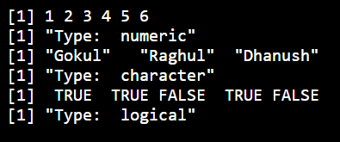
RESULT:
Hence the output is verified successfully
2.AIM:
To create labeled matrices (5×4, 3×3, 2×2) filled by row/column.
ALGORITHM:
1. Open RStudio or R console.
2. Create a 5×4 matrix using a sequence of numbers.
3. Display the matrix.
4. Create a 3×3 matrix.
5. Display the matrix.
6. Create a 2×2 matrix.
7. Display the matrix.
8. Observe the arrangement of rows and columns.
CODING:
a = matrix(1:20,nrow=5,ncol=4)
a

b = matrix(1:9,nrow=3,ncol=3)
b

c = matrix(1:4,nrow=2,ncol=2)
c
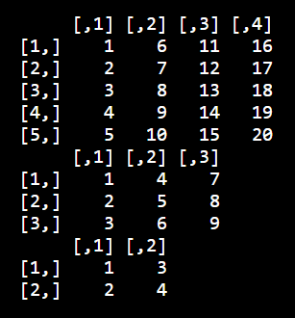
RESULT:
Hence the ouput is verified successfully.

3.AIM:
To write an R program to create and display a 3D array with specified rows, columns, and tables.
ALGORITHM:
1. Open RStudio or R console.
2. Create a sequence of numbers.
3. Use the array() function.
4. Specify the dimensions as rows, columns, and tables.
5. Store the array in a variable.
6. Display the array.
CODING:
a = 1:24
arr = array(a, dim=c(2,3,4))
arr

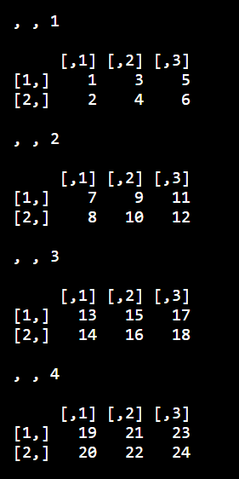
RESULT:
Hence the output is verified successfully.
4.AIM
To create arrays from vectors with dimension names, print specific elements.
ALGORITHM
1. Create a sequence of numbers.
2. Store the sequence in a variable.
3. Create an array using array().
4. Specify the dimensions.
5. Store the array in another variable.
6. Display the array.
7. Access a specific element using row, column, and table position.
8. Print the selected element.
CODING
a = 1:8
b = array(a, dim=c(2,2,2))
b
print(b[2,1,2])
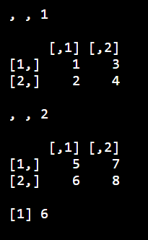
RESULT
Hence the output is verified successfully.

5.AIM
Create and manipulate factor variables (e.g., women’s dataset heights, random LETTERS sample).
ALGORITHM
1. Create a character vector containing categorical values.
2. Convert the character vector into a factor.
3. Display the factor.
4. Set a random seed.
5. Generate random letters from A to E.
6. Convert the generated letters into a factor.
7. Display the factor and its levels.
CODING
a = c("Short","Medium","Tall","Medium","Tall","Short")
b = factor(a)
print(b)

set.seed(10)
c = sample(LETTERS[1:5], 8, replace = TRUE)
d = factor(c)
print(d)
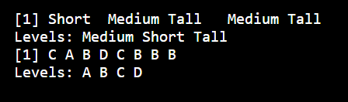
RESULT
Hence the output is verified successfully.

6.AIM
To create an R list containing vectors, matrices, and functions; display contents.
ALGORITHM
1. Create a numeric vector.
2. Create a matrix.
3. Define a function.
4. Combine the vector, matrix, and function using list().
5. Give names to the list components.
6. Display the complete list.
CODING
a = c(1, 2, 3, 4)
b = matrix(1:6, nrow = 2, ncol = 3)
c = function(x) x^2

mylist = list(Vector = a, Matrix = b, Function = c)
print(mylist)
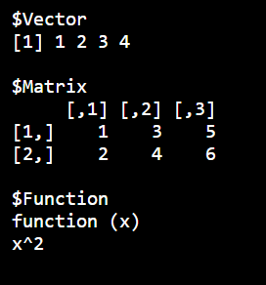
RESULT
Hence the output is verified successfully.

7.AIM
To write R programs for basic tasks: Factors of a number, generate a vector of 10 random integers between -50 and 50, print numbers 1–100 with FizzBuzz logic.
ALGORITHM
1. Assign a number to a variable.
2. Create an empty vector to store factors.
3. Use a for loop from 1 to the given number.
4. Check divisibility using the modulus operator.
5. Add the divisor to the factors vector.
6. Print the factors.
7. Set a random seed.
8. Generate 10 random integers between -50 and 50.
9. Use a for loop from 1 to 100.
10. If divisible by both 3 and 5, print FizzBuzz.
11. If divisible by 3, print Fizz.
12. If divisible by 5, print Buzz.
13. Otherwise print the number.
CODING
n <- 12L
factors <- integer(0)

for (i in seq_len(n)) {
if (n %% i == 0) {
factors <- c(factors, i)
}
}

print("Factors of the number:")
print(factors)

set.seed(123)

print("10 random integers:")
print(sample(-50:50, 10, replace = TRUE))

for (i in 1:100) {
if (i %% 15 == 0)
print("FizzBuzz")
else if (i %% 3 == 0)
print("Fizz")
else if (i %% 5 == 0)
print("Buzz")
else
print(i)
}
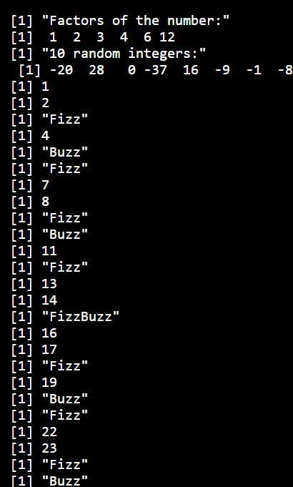
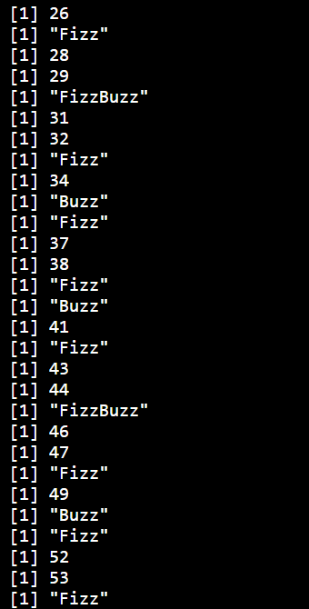
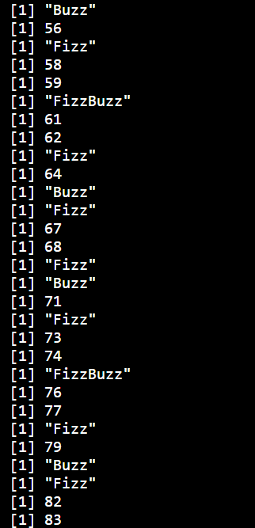
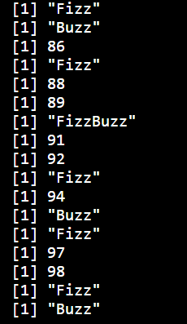

RESULT
Hence the output is verified successfully.

8.AIM
To generate random numbers from a normal distribution; count occurrences.
ALGORITHM
1. Set a random seed.
2. Generate 100 random numbers using rnorm().
3. Round the generated numbers.
4. Count the occurrences using table().
5. Convert the frequency table into a data frame.
6. Display the frequency table.
CODING
set.seed(123)
x <- rnorm(100)
y <- table(round(x))

print(as.data.frame(y))
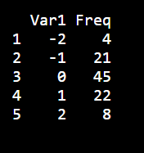
RESULT
Hence the output is verified successfully.

9.AIM
To create empty plots with specified axis limits.
ALGORITHM
1. Remove the variable c from the workspace.
2. Use plot() with type = "n".
3. Set x-axis limits using xlim.
4. Set y-axis limits using ylim.
5. Add x-axis and y-axis labels.
6. Display the empty plotting area.
CODING
plot(1,
type = "n",
xlim = c(0, 10),
ylim = c(0, 100),
xlab = "x axis",
ylab = "y axis")
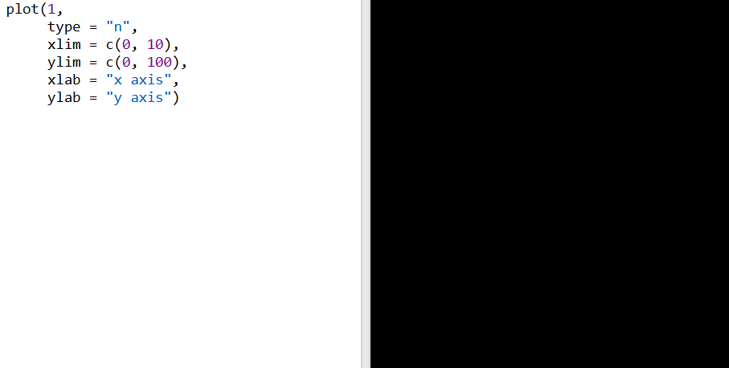
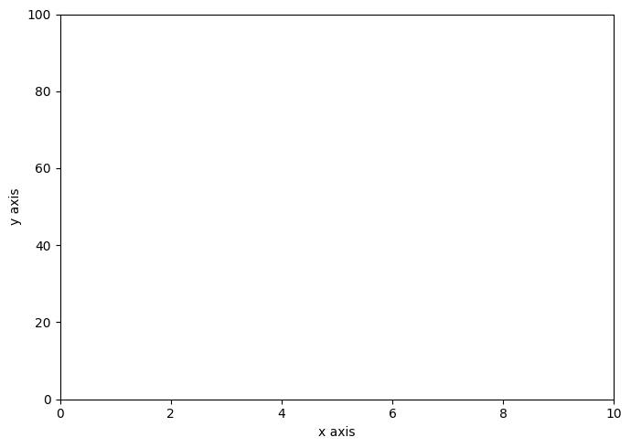

RESULT
Hence the output is verified successfully.

10.AIM
To create and explore a data frame exam_data with name, score, attempts, and qualifying fields. Perform extract, add row/column, sort, save to file.
ALGORITHM
1. Create a data frame with name, score, attempts and qualify columns.
2. Add a new student using rbind().
3. Add a grade column.
4. Sort the data frame in descending order of score.
5. Save the data frame as a CSV file using write.csv().
6. Display the final data frame.
CODING
x <- data.frame(
name = c("Anu","Bala","Charan","Divya","Esha"),
score = c(85,62,90,75,88),
attempts = c(1,3,2,2,1),
qualify = c("yes","no","yes","no","yes")
)

x <- rbind(x, data.frame(name="Farhan",
score=70,
attempts=3,
qualify="no"))

x$grade <- c("A","C","A+","B","A","B")

x <- x[order(-x$score),]

write.csv(x, "x.csv", row.names=FALSE)

print(x)
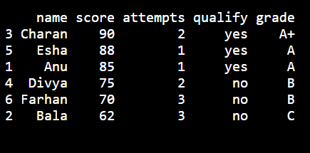

RESULT

Hence the output is verified successfully.

